HegTool Installation Demonstration

Image Downloader Project (2024)

These instructions walk you through installing HegTool on your computer. Note you may

need administrative privileges to do this. Feel free to read README_INSTALL_Win_v2.15.txt for installation instruction provided by NASA or EED2-TP-030_Rev01_HEG_UsersGuide_2.15.pdf for the full HegTool documentation which can be found on the GitHub page.

Make sure you have java (jdk1.8 or jre8 or newer windows version) installed on your computer before starting. You may need more updated java depending on the future HegTool versions.

1. Download “hegWINv2.15.zip” from this website: [Release 2.15 (April 2019) - Data Access Services - Earthdata Wiki (nasa.gov)](https://wiki.earthdata.nasa.gov/pages/viewpage.action?pageId=170800766) or newer version.

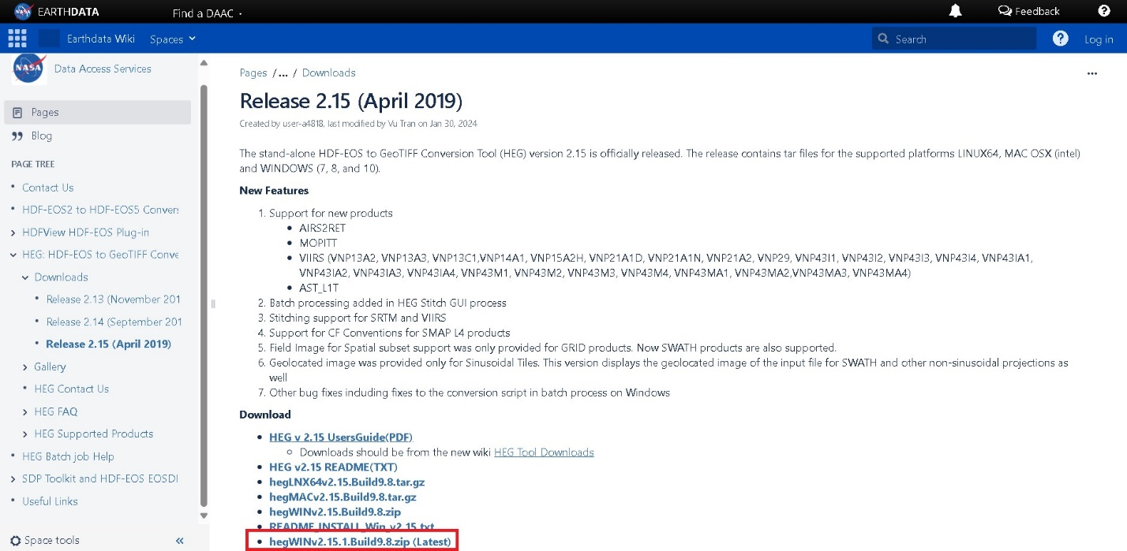

1. Create a directory folder for the HegTool. Make sure that there are no spaces in any of the folder names on this path. Ex: C:\Users\zachs\Desktop\Heg_Tool
2. Unzip the hegWINv2.15.zip into the folder you just created.
3. Run the install.bat by double clicking and follow the steps.

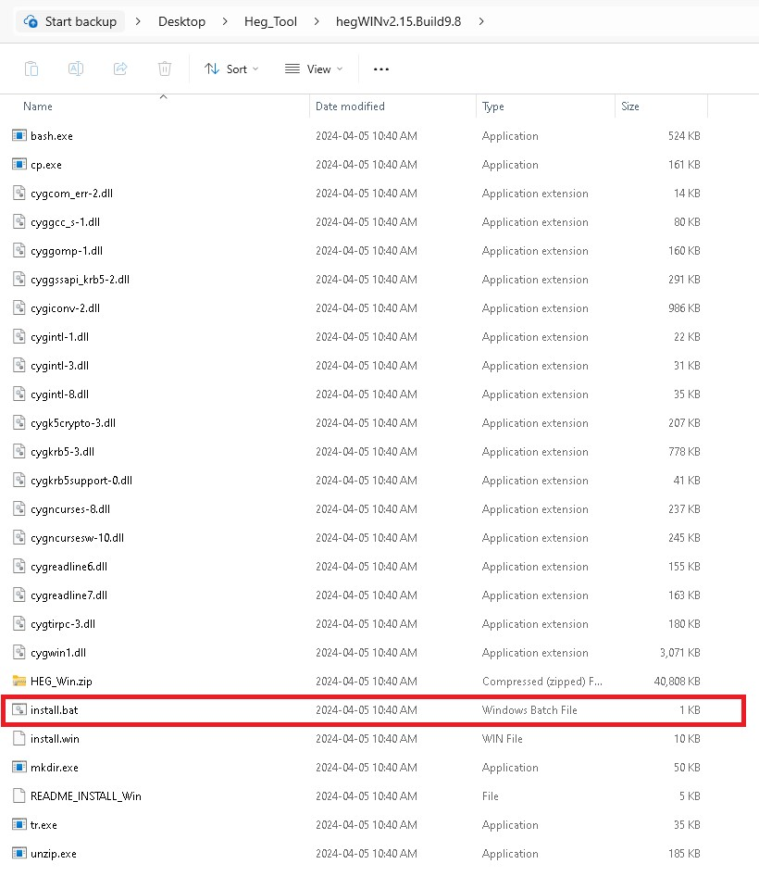

1. This screen will appear press y then enter

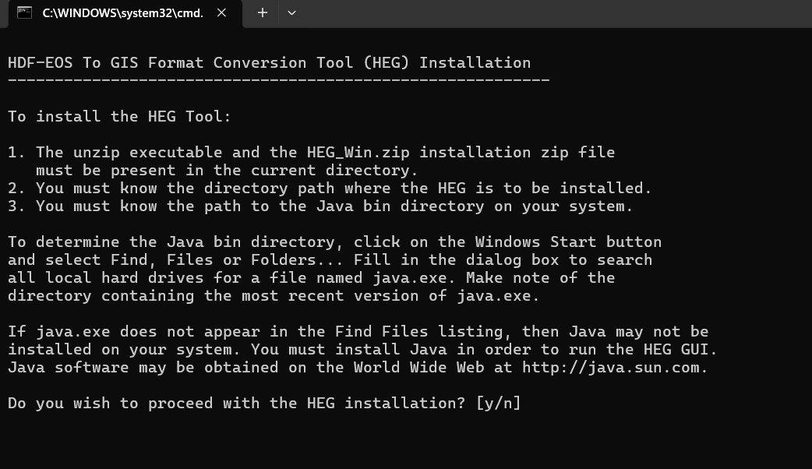

1. Enter the Heg full directory path. Ex. C:/Users/zachs/Desktop/Heg_Tool/HEG then enter y. Make sure you use the front slash for your path.

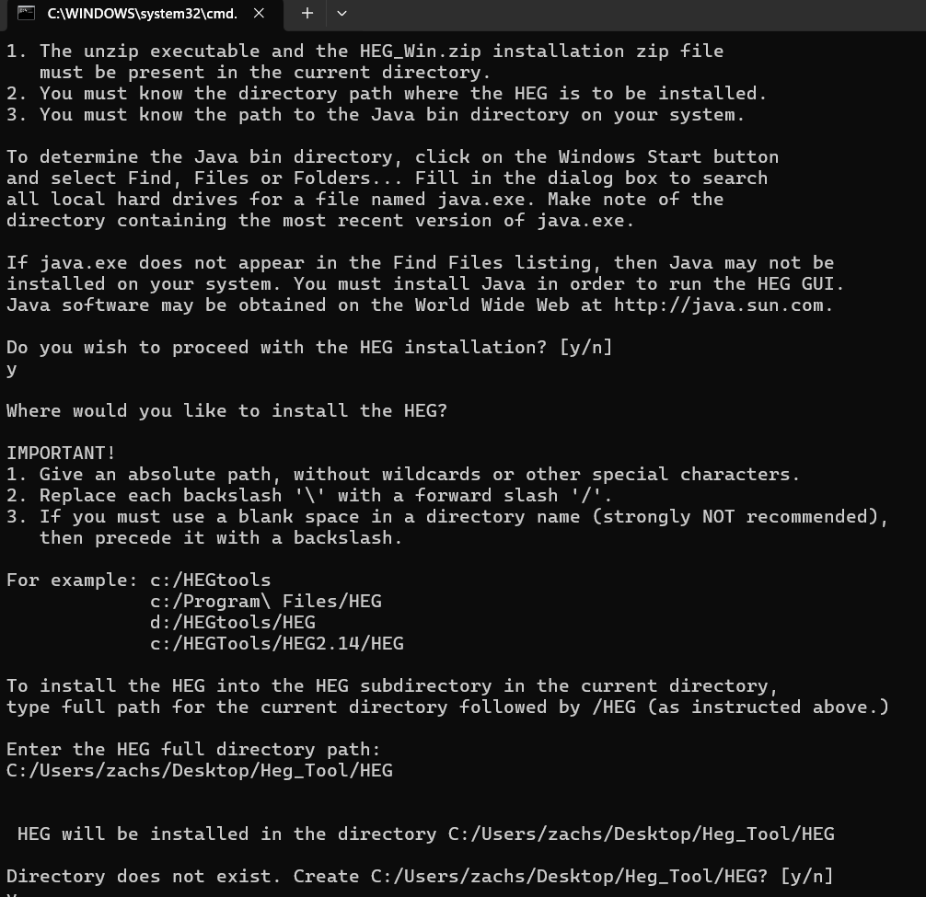

1. Now locate the path to your java bin directory on your computer. The java files are usually found on the C: drive within the Program Files. Make sure you use the front slash for your path.

Ex. C:/Program Files (x86)/Java/jre-1.8/bin

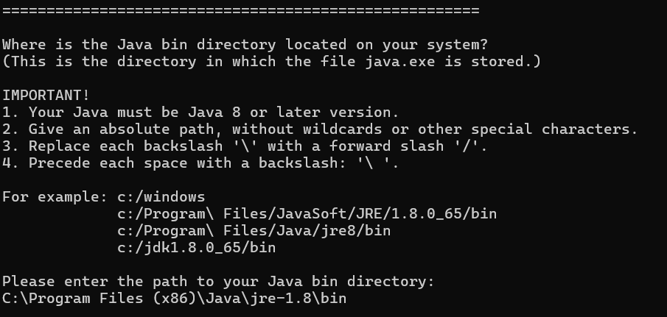

1. Enter any username you would like; the user’s name is not needed for this Image Downloader Project.
2. Press the ENTER key twice to create the HEGTool.bat and to continue. (If you do not have java on your computer the HEGTool.bat will not be created)

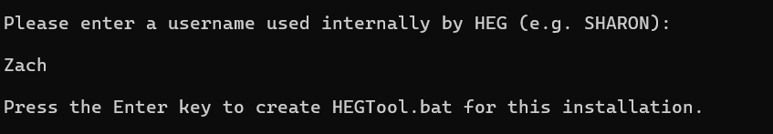

1. You should get this screen if the download was successful. Press ENTER to exit.

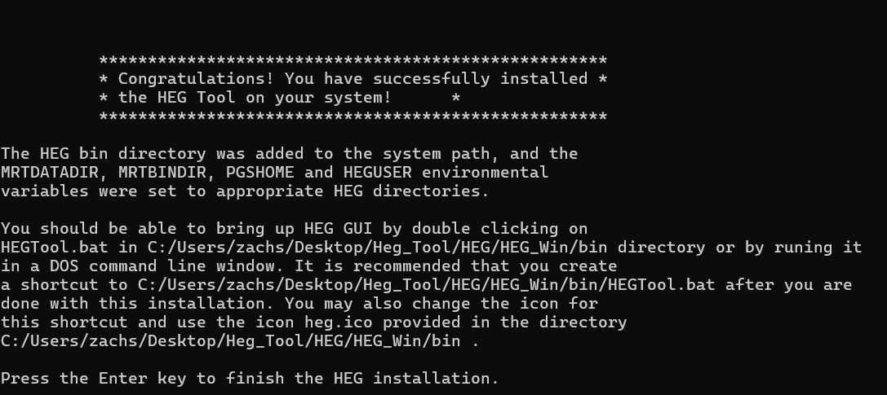

1. If you go into the bin directory (ex. C:/Users/zachs/Desktop/Heg_Tool/HEG/HEG_Win/bin) that is created with the install you will find the HEGTool.bat file (The heg.bat file is not the correct one). Double click on it to run the HegTool.

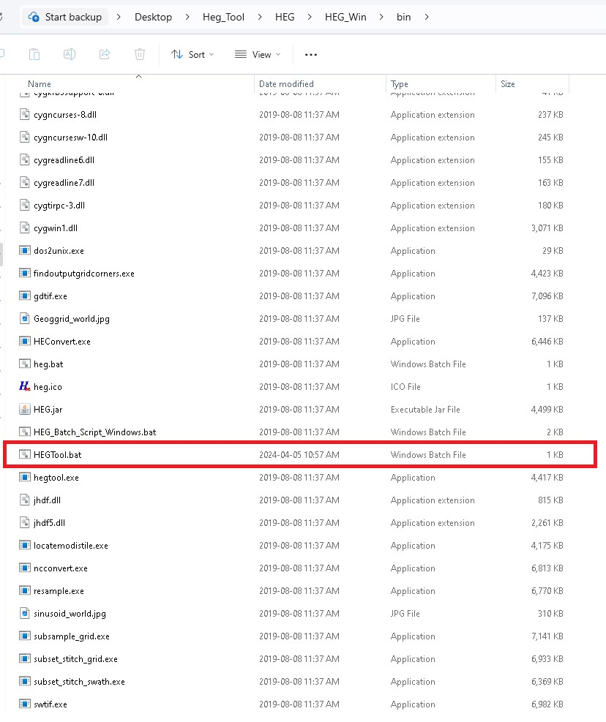

1. Running the HEGTool.bat will open a command terminal with the HegTool running inside. You should get a screen that looks like this. Now you can get started on using the HegTool.

